**Semester 2 (Units 3 and 4) Examination, 2017**

**Question/Answer Booklet**

**MATHEMATICS METHODS**

**Section Two: Calculator-assumed**

Student Name/Number: ______________________________________________

Teacher Name: ______________________________________________

**Time allowed for this section**

Reading time before commencing work: ten minutes

Working time for this section: hundred minutes

**Materials required/recommended for this section**

**To be provided by the supervisor:** This Question/Answer Booklet

Formula Sheet (retained from Section One)

**To be provided by the candidate:**

Standard items: pens (blue/black preferred), pencils (including coloured), sharpener, correction fluid/tape, eraser, ruler, highlighters

Special items: drawing instruments, templates, notes on ____ unfolded sheets of A4 paper, and up to three calculators approved for use in the WACE examinations

**Important note to candidates**

No other items may be taken into the examination room. It is **your** responsibility to ensure that you do not have any unauthorised notes or other items of a non-personal nature in the examination room. If you have any unauthorised material with you, hand it to the supervisor **before** reading any further.

**Structure of this paper**

|  |  |  |  |  |  |
| --- | --- | --- | --- | --- | --- |
| Section | Number of questions available | Number of questions to be answered | Working time (minutes) | Marks available | Percentage of exam |
| Section One: Calculator-free | 9 | 9 | 50 | 52 | 35 |
| Section Two: Calculator-assumed | 13 | 13 | 100 | 99 | 65 |
|  | | | | | 100 |

**Instructions to candidates**

1. The rules for the conduct of School exams are detailed in the *_______________________________________School/College assessment policy*. Sitting this examination implies that you agree to abide by these rules.
2. Write your answers in this Question/Answer Booklet.

3. You must be careful to confine your responses to the specific questions asked and to follow any instructions that are specific to a particular question.

1. Spare pages are included at the end of this booklet. They can be used for planning your responses and/or as additional space if required to continue an answer.
   * Planning: If you use the spare pages for planning, indicate this clearly at the top of the page.
   * Continuing an answer: If you need to use the space to continue an answer, indicate in the original answer space where the answer is continued, i.e. give the page number. Fill in the number of the question that you are continuing to answer at the top of the page.
2. **Show all working clearly.** Your working should be in sufficient detail to allow your answers to be checked readily and for marks to be awarded for reasoning. Incorrect answers given without supporting reasoning cannot be allocated any marks. For any question or part question worth more than two marks, valid working or justification is required to receive full marks. If you repeat any question, ensure that you cancel the answer you do not wish to have marked.
3. It is recommended that you **do not use pencil**, except in diagrams.
4. The Formula Sheet is **not** to be handed in with your Question/Answer Booklet.

**Section Two: Calculator-assumed (99 Marks) Weighting 65%**

This section has **(thirteen)** **13** questions. Answer **all** questions. Write your answers in the spaces provided. Spare pages are included at the end of this booklet.

Suggested working time: **100 minutes**.

**Question 10 (6 marks)**

The half-lives of the radioactive isotopes A and B are 157 years and 359 years respectively.

(a) Which isotope is decaying the faster? Justify your answer. (2 marks)

(b) At present the concentrations of isotopes A and B in a particular chemical compound are equal. How long will it take before the ratio of the concentrations is 100 to 1? Give your answer correct to the nearest year. (4 marks)

**Question 11 (6 marks)**

A researcher asked 100 voters from a certain town who they would be voting for in the upcoming election. The proportion who said they would vote for Dr Alexander was 35%.

(a) State the population and the sample in this case. (2 marks)

(b) Explain one method that would allow to select an unbiased random sample of 100 voters. (1 mark)

(c) Assuming the original sample of 100 was an unbiased random sample, determine the probability that in another sample of 200 voters, between 30% and 40% would vote for Dr Alexander. (3 marks)

**Question 12 (6 marks)**

The Bernesse family live one kilometre from their school. On the route they drive to school are two school crosswalks. The probability that they will have to stop at each cross walk is $\frac{3}{5}$ independent of each other.

(a) Illustrate the sample space for the above situation using a tree diagram. (2 marks)

Let ‘c’ represent the number of times the car must stop at a crosswalk.

(b) Complete the following probability distribution table for this random variable. (2 marks)

|  |  |  |  |
| --- | --- | --- | --- |
| **c** | 0 | 1 | 2 |
| **Pr(C = c)** |  |  |  |

(c) After five weekdays, what is the expected value of times the Bernesse family must stop at least once on their way to school. (2 marks)

**Question 13 (6 marks)**

A train stops at a certain train station 15 times a day and is late 30% of the time.

Calculate, correct to 3 decimal places,

(a) the probability that the train will be late 4 times, on any particular day. (2 marks)

(b) the probability that the train is late 4 times for at least 2 out of the next 8 days. (3 marks)

(c) the probability that the first three trains of the day are on time and the fourth is late.

(1 mark)

**Question 14 (7 marks)**

1. The noise level () of a rock band is given by the relationship. 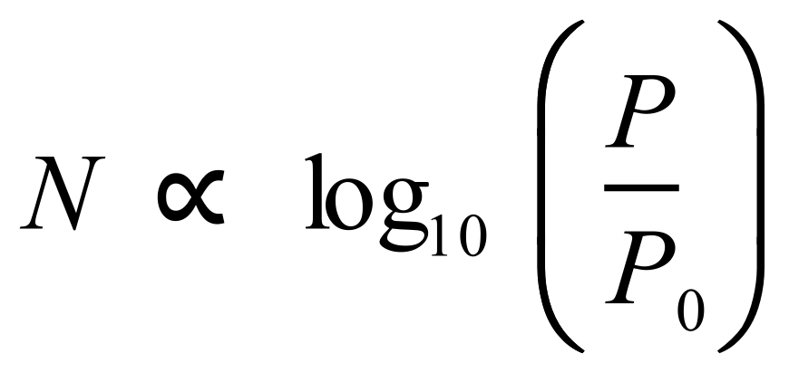, where  is the noise level in decibels,  is the acoustic power and 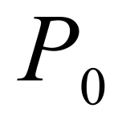 is a reference power level.

If a rock band increases the acoustic power of its musical output by a factor of 10, the noise level increases by 10 decibels.

By how much will the noise level increase, if the power increases by a factor of 40?

(2 marks)

1. To help pass time while marooned on a desert island, a computer scientist constructs a table of base 10 logarithms using approximations involving whole numbers. Her starting point is the familiar approximation involving a power of 2: 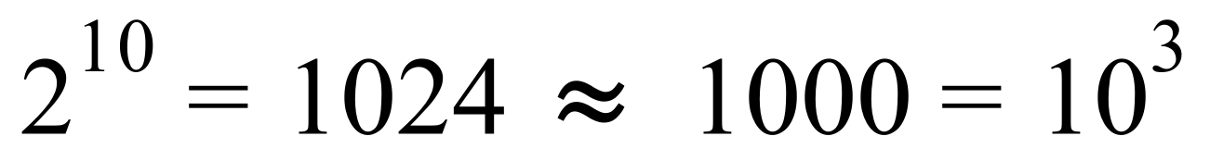 from which it follows that 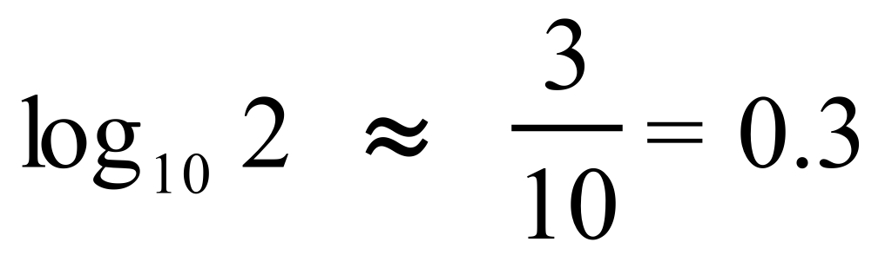 .
2. Use a similar approximation and the approximate value of 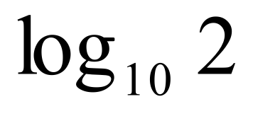 to estimate  . (2 marks)
3. Evaluate 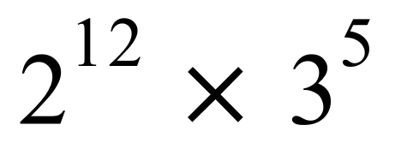 and use this to estimate 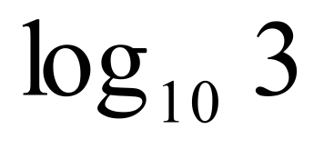. (3 marks)

**Question 15 (10 marks)**

It is predicted that in the year 2018 the number of daylight hours, between sunrise and sunset, in a city of southern New Zealand will be given by the formula

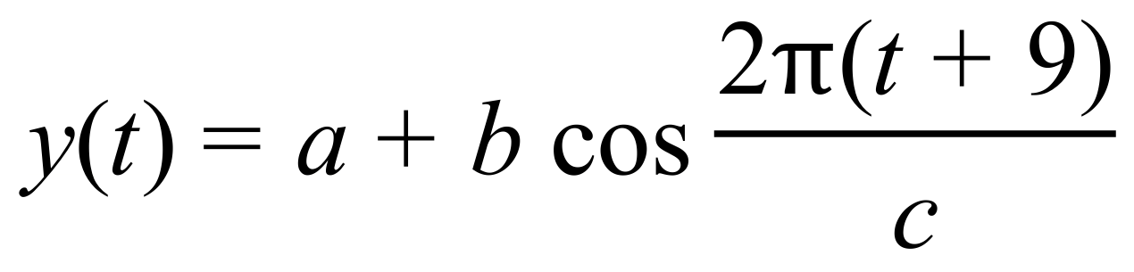

where 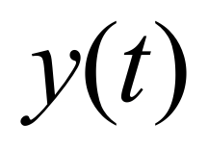 is the number of daylight hours on day 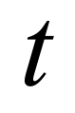 of the new year, and 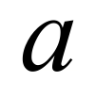, 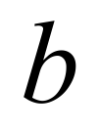 and 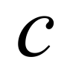 are positive constants. The longest day, that is, the day with the greatest number of daylight hours, has 14.5 hours of daylight, and the shortest day has 9.5 hours of daylight.

(a) Evaluate the constants ,  and  given that the number of daylight hours follows a yearly cycle. (3 marks)

(b) Use the formula to determine the day in 2018 with the most daylight. (2 marks)

(c) On what day will the daily amount of daylight be decreasing the fastest? (3 marks)

(d) Use the increments formula to estimate the largest difference between the number of daylight hours on successive days. (2 marks)

**Question 16 (10 marks)**

A logging company makes logs of length X metres.

The values of X are normally distributed with a mean of 3.5 and a standard deviation of 0.2.

(a) Find the probability that the length of a randomly chosen log

(i) is exactly 3.5 metres. (1 mark)

(ii) exceeds 3.2 metres. (1 mark)

1. is less than 3.5 metres given that it is at least 3.2 metres long. Include a clear illustration with your working. (3 marks)
2. The probability of obtaining a log with a length of no more than $m$ metres is 0.8.

Show how to determine $m$. (2 marks)

1. To improve the consistency of the length of the logs, the company decides to reduce the proportion of logs exceeding 3.7 metres, to 10% while maintaining the same mean. Determine the new standard deviation, stating your answer to the nearest centimetre.

(3 marks)

**Question 17 (7 marks)**

The acceleration of a particle is given by $a=3\sin\left(2t\right)$ where distance is measure in metres and time, *t*, in seconds. Initially, the velocity of the particle is 4 m/s and its distance from the equilibrium position is 2 metres.

1. Determine an equation for the velocity of the particle. (3 marks)

1. Determine the displacement of the particle when *t* = 2 (accurate to 2 decimal places).

(4 marks)

**Question 18 (8 marks)**

(a) State the 30th percentile for standard normal distribution. (2 marks)

(b) Given that $X$ is a normal random variable with mean of 16 and a standard deviation of 3, determine the value of $k$ for which $P(X+1>3k)=0.6$. (2 marks)

(c) Explain the following statement in terms of $μ$ and $σ$.

*A standard score of 2.4 has a corresponding x-value of 6.* (1 mark)

(d) When X has a probability density function, $f\left(x\right)=3x^{2}$ for $0<x<1$, determine the cumulative distribution function $F(x)$. (3 marks)

**Question 19 (5 marks)**

A survey of 1000 students reports that 48% are excited by the upcoming concert by a well- known celebrity. Construct a 95% confidence interval on the true proportion of students who are excited by the concert.

**Question 20 (11 marks)**

1. The graph below shows the velocity (in *m/s*) of a projectile at time  seconds after launch.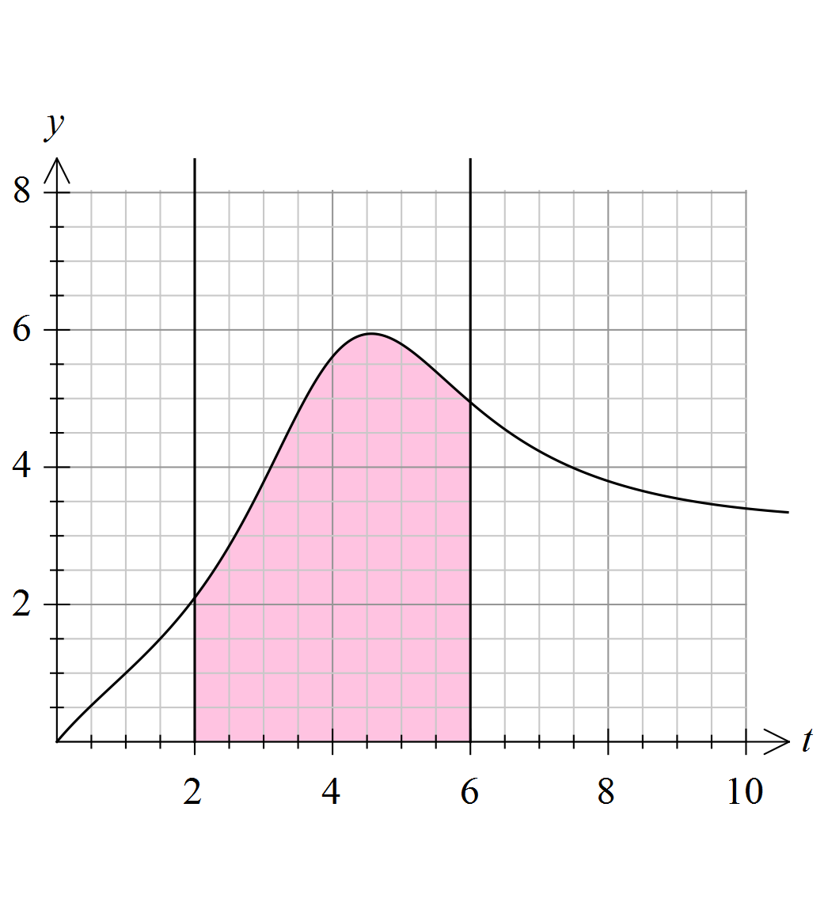
2. Estimate the area of the shaded region by evaluating  where  for all  and . (4 marks)
3. What does this area represent? (1 mark)

**Question 20 (continued)**

1. Region A, on the graph below, is defined as the area enclosed between the  axis,  while Region B, is defined as the area enclosed between and .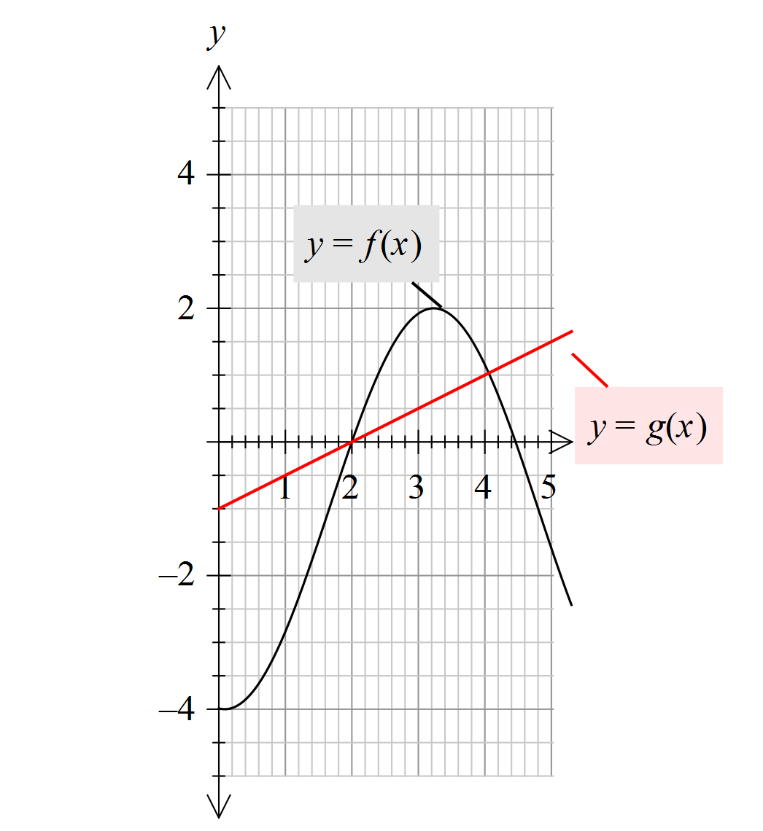

A

B

The following information is known:



1. Determine the area of Region A. (2 marks)
2. Show that the area of Region B = 1.92 (4 marks)

**Question 21 (12 marks)**

(a) Evaluate 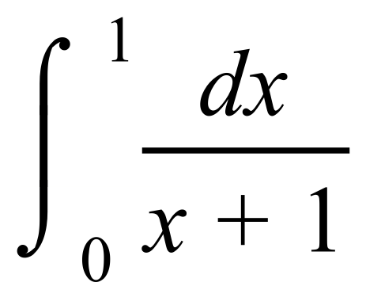 exactly. (2 marks)

(b) Evaluate 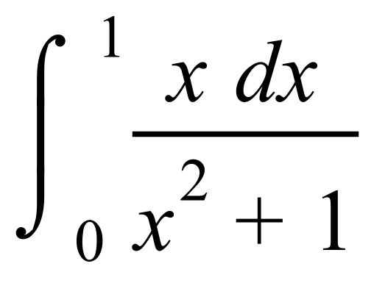 exactly. (2 marks)

1. Heat escapes from a hot water storage tank such that the rate of loss, in kilojoules per day, is given by



where  is the total accumulated heat loss on day  a given year.

1. Determine the values of  , to the nearest day, at which the rate of heat loss reaches its maximum? State the maximum rate of heat loss per day. (3 marks)
2. Determine the heat loss between  (3 marks)

**Question 21 (c) (continued)**

A hot water storage tank located in a different State of Australia has a heat loss rate defined by



1. Determine , if the heat lost between is known to be 300 kilojoules. (2 marks)

**Question 22 (5 marks)**

1. On the axes provided below, sketch the graph of for  .

(3 marks)

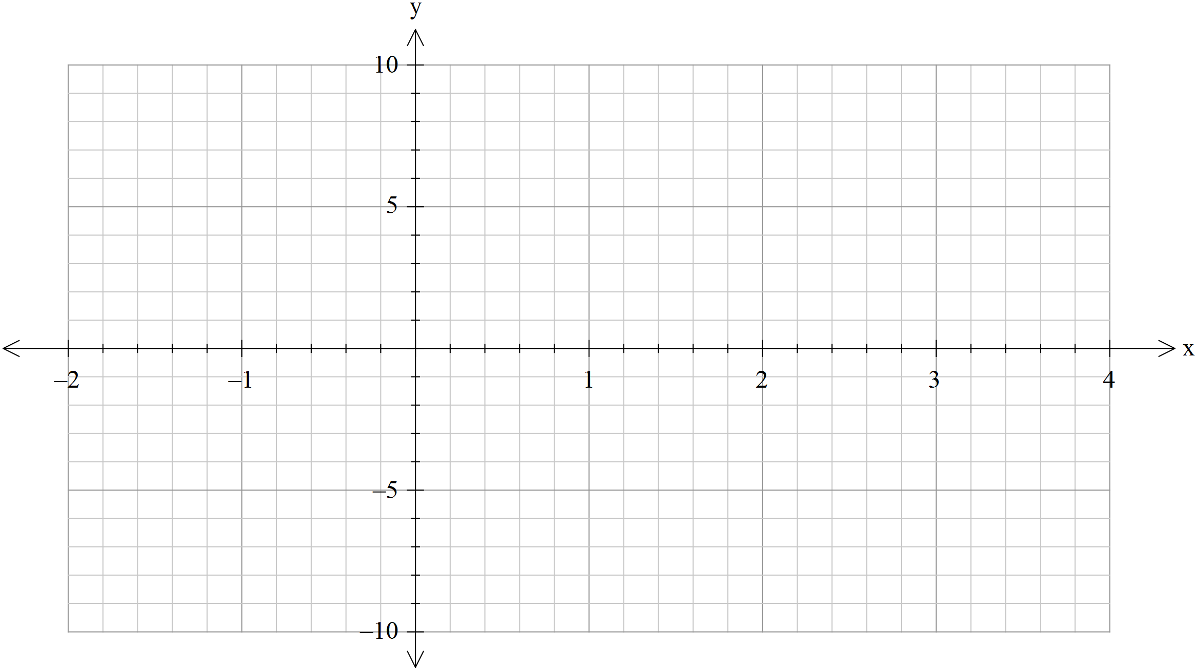

1. Determine  such that  (2 marks)

**End of questions**

Additional working space

Question number: __________________

**Acknowledgements**

© MAWA, 2017

This examination is Copyright but may be freely used within the school that purchases this licence.

* The items that are contained in this examination are to be used solely in the school for which they are purchased.
* They are not to be shared in any manner with a school which has not purchased their own licence.
* The items and the solutions/marking keys are to be kept confidentially and not copied or made available to anyone who is not a teacher at the school. Teachers may give feedback to students in the form of showing them how the work is marked but students are not to retain a copy of the paper or the marking guide until the agreed release date stipulated in the purchasing agreement/licence.

*Published by The Mathematical Association of WA*

*12 Cobbler Place, MIRRABOOKA 6061*